SMART VILLAGE RESOURCE MANAGEMENT SYSTEM

- Abstract
The Smart Village Management System is a C++-based console application developed to manage village-level administrative data efficiently. The system handles citizen records, complaints, water usage, electricity billing, and waste management using linked lists.
Unlike traditional file-based systems, this implementation utilizes dynamic memory allocation through linked lists, enabling efficient insertion and traversal operations. The project demonstrates the practical application of data structures in solving real-world problems related to rural administration.

2. Introduction

2.1 Background
Village administration traditionally relies on manual record-keeping, which leads to inefficiencies, data redundancy, and difficulty in data retrieval. Managing multiple domains such as citizens, complaints, and utilities becomes increasingly complex without a structured system.

2.2 Need for the System
- Manual systems are error-prone
- Lack of centralized data management
- Difficult to track complaints and services
- Inefficient billing processes

2.3 Proposed Solution
The proposed system is a menu-driven application that uses linked lists to dynamically store and manage data. It provides an efficient and modular approach to handle different village management tasks.

3. Objectives
- To digitize village data management
- To implement linked lists in a real-world application
- To manage citizen and complaint records
- To calculate utility bills efficiently
- To design a modular and scalable system

4.System Modules
- Citizen Management
- Complaint Management
- Water Billing System
- Electricity Billing System
- Waste Management

5.Data Structures Used

Singly Linked List
Used for:
- Citizen Records
- Water Records
- Electricity Records
- Waste Records

Doubly Linked List
Used for:
- Complaint Management (for easier updates and traversal)

6.Justification of Data Structures
Linked lists are used because:
- They allow dynamic memory allocation
- No fixed size limitation
- Efficient insertion without shifting elements
Doubly linked lists are used for complaints to:
- Enable easier updates
- Allow bidirectional traversal if needed

7.Methodology
- The system starts and displays a main menu
- User selects a module
- User performs operations like Add, Display, or Update
- Data is stored dynamically using linked lists
- Records are displayed using traversal
- The system repeats until the user exits

8.Module Description

8.1 Citizen Management Module
- Stores ID, Name, Age
- Operations:
  - Add citizen
  - Display citizens
- Data Structure: Singly Linked List

8.2 Complaint Management Module
- Stores complaint ID, text, and status
- Operations:
  - Add complaint
  - Display complaints
  - Update status
- Data Structure: Doubly Linked List

8.3 Water Management Module
- Stores consumer ID and units
- Calculates bill using fixed rate
- Data Structure: Singly Linked List

8.4 Electricity Management Module
- Stores consumer ID and units
- Uses slab-based billing
- Data Structure: Singly Linked List

8.5 Waste Management Module
- Stores waste type and quantity
- Data Structure: Singly Linked List

9. Algorithm

General Algorithm
- Start
- Initialize all head pointers to NULL
- Display main menu
- Read user input
- Perform operation based on choice
- Repeat until exit
- Stop

Example: Add Citizen
- Create a new node
- Input ID, name, age
- Insert node at head
- Update pointer

10. Billing Logic

Water Billing
Bill = Units × 2.5

Electricity Billing
- ≤100 → Units × 3
- ≤300 → 100×3 + (Units−100)×5
- 300 → 100×3 + 200×5 + (Units−300)×7
FLOWCHART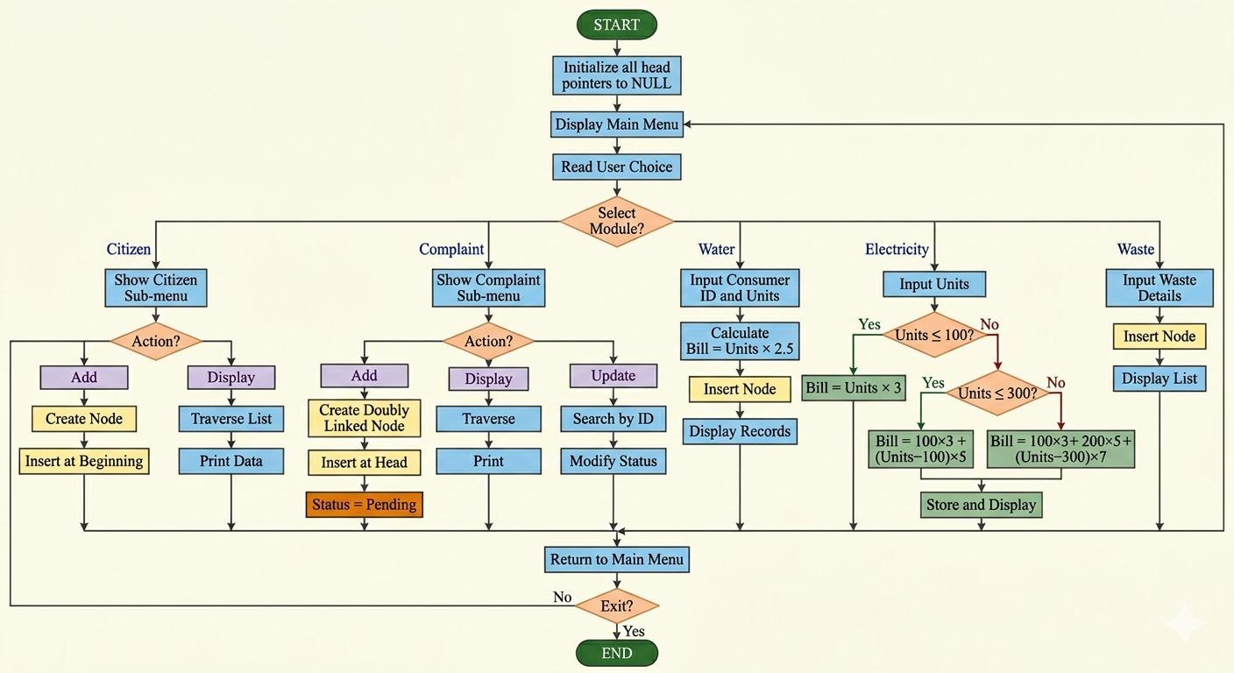

13. Advantages
- Efficient memory utilization
- Fast insertion operations
- Modular design
- Easy to understand and implement

14. Limitations
- No persistent storage
- No graphical interface
- Limited operations (no search/delete)

15. Applications
- Village administration
- Small municipal systems
- Local governance data management

16. Future Scope
- Integration with database systems
- Development of GUI
- Authentication and security features
- Web/mobile-based implementation

17. Conclusion
The Smart Village Management System demonstrates the effective use of linked lists in handling real-world data. The system provides a structured and efficient approach to managing village operations and can be extended for larger-scale applications.

18. References
- Bjarne Stroustrup, The C++ Programming Language
- E. Balagurusamy, Object Oriented Programming with C++
- Mark Allen Weiss, Data Structures and Algorithms in C++
- GeeksforGeeks – Linked Lists
- TutorialsPoint – C++

SAMPLE OUTPUT
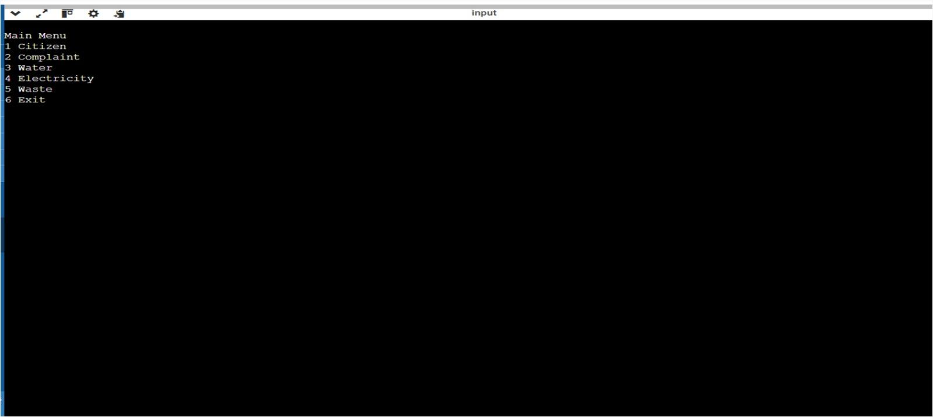

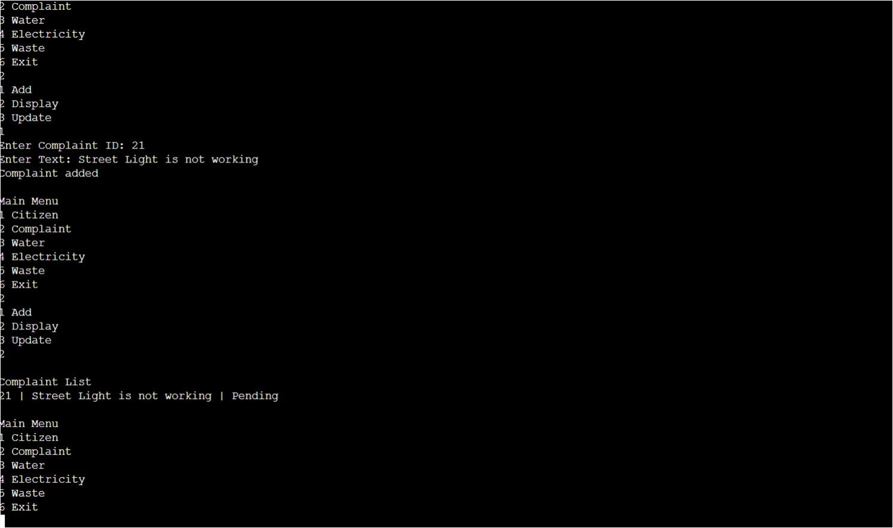

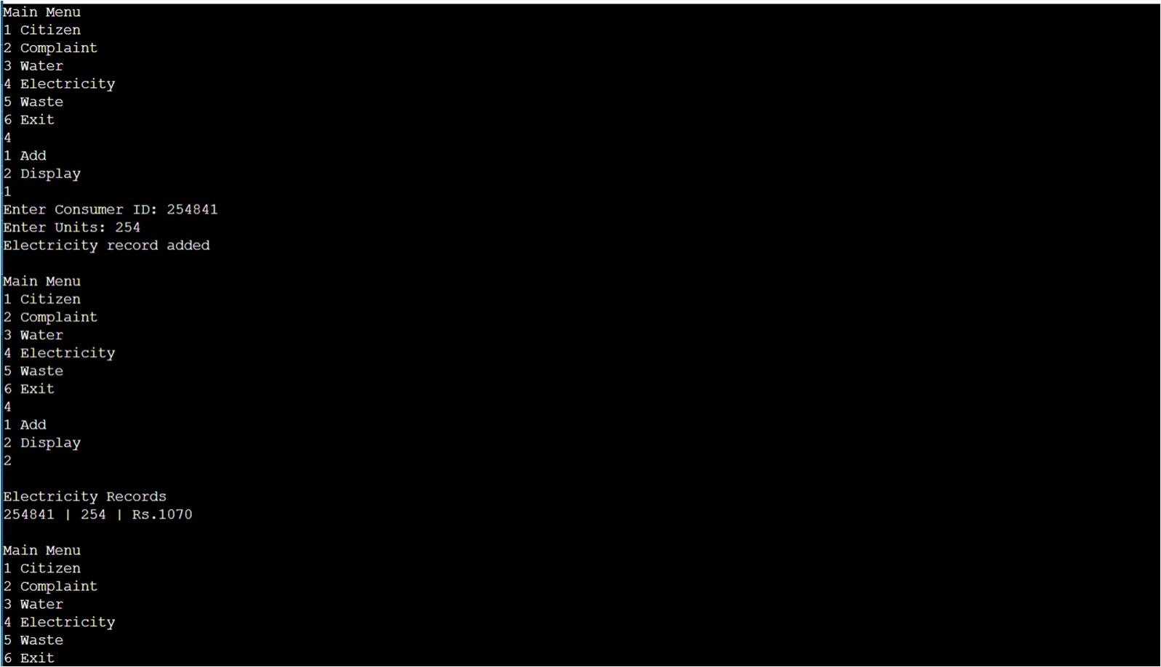

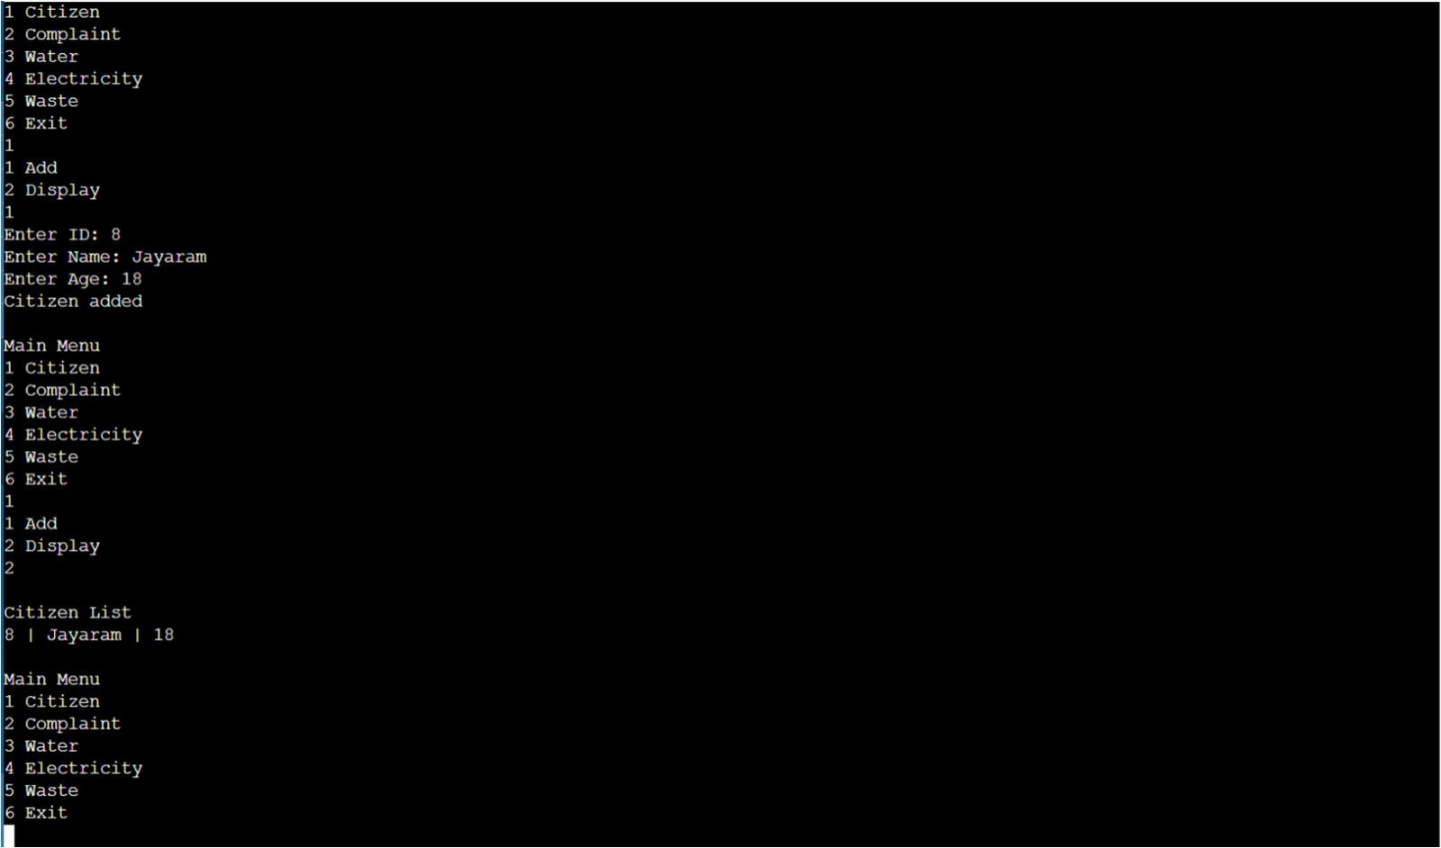
Appendix: Complete Source Code
Code Description
The program is structured into multiple modules using functions. Each module manages a specific component such as citizens, complaints, or utilities. Linked lists are used for dynamic data storage, and operations such as insertion and traversal are implemented.
// Header files
#include <iostream>
#include <string>
using namespace std;

// Structure definitions

// Citizen structure
struct Citizen {
int id;
int age;
string name;
Citizen* next;
};

// Complaint structure (Doubly Linked List)
struct Complaint {
int id;
string text;
string status;
Complaint* next;
Complaint* prev;
};

// Water record structure
struct WaterRecord {
int consumerId;
int units;
float bill;
WaterRecord* next;
};

// Electricity record structure
struct ElectricityRecord {
int consumerId;
int units;
float bill;
ElectricityRecord* next;
};

// Waste record structure
struct WasteRecord {
int id;
string type;
int quantity;
WasteRecord* next;
};

// Global head pointers
Citizen* citizenHead = NULL;
Complaint* complaintHead = NULL;
WaterRecord* waterHead = NULL;
ElectricityRecord* electricityHead = NULL;
WasteRecord* wasteHead = NULL;

// Citizen module

// Add citizen
void addCitizen() {
Citizen* node = new Citizen();
cout << "Enter ID: ";
cin >> node->id;
cout << "Enter Name: ";
cin >> node->name;
cout << "Enter Age: ";
cin >> node->age;
node->next = citizenHead;
citizenHead = node;
cout << "Citizen added\n";
}

// Display citizens
void displayCitizens() {
if (citizenHead == NULL) {
cout << "No citizens found\n";
return;
}

Citizen* temp = citizenHead;
while (temp != NULL) {
cout << temp->id << " | " << temp->name << " | " << temp->age << endl;
temp = temp->next;
}
}

// Complaint module

// Add complaint
void addComplaint() {
Complaint* node = new Complaint();
cout << "Enter Complaint ID: ";
cin >> node->id;
cin.ignore();
cout << "Enter Text: ";
getline(cin, node->text);
node->status = "Pending";
node->prev = NULL;
node->next = complaintHead;

if (complaintHead != NULL)
complaintHead->prev = node;

complaintHead = node;
cout << "Complaint added\n";
}

// Display complaints
void displayComplaints() {
if (complaintHead == NULL) {
cout << "No complaints\n";
return;
}

Complaint* temp = complaintHead;
while (temp != NULL) {
cout << temp->id << " | " << temp->text << " | " << temp->status << endl;
temp = temp->next;
}
}

// Update complaint status
void updateComplaintStatus() {
int id;
cout << "Enter Complaint ID: ";
cin >> id;

Complaint* temp = complaintHead;
while (temp != NULL) {
if (temp->id == id) {
cout << "Enter new status: ";
cin >> temp->status;
cout << "Updated\n";
return;
}
temp = temp->next;
}

cout << "Not found\n";
}

// Water module

// Add water record
void addWaterRecord() {
WaterRecord* node = new WaterRecord();
cout << "Enter Consumer ID: ";
cin >> node->consumerId;
cout << "Enter Units: ";
cin >> node->units;
node->bill = node->units * 2.5;
node->next = waterHead;
waterHead = node;
cout << "Water record added\n";
}

// Display water records
void displayWaterRecords() {
if (waterHead == NULL) {
cout << "No water records\n";
return;
}

WaterRecord* temp = waterHead;
while (temp != NULL) {
cout << temp->consumerId << " | " << temp->units << " | Rs." << temp->bill << endl;
temp = temp->next;
}
}

// Electricity module

// Add electricity record
void addElectricityRecord() {
ElectricityRecord* node = new ElectricityRecord();
cout << "Enter Consumer ID: ";
cin >> node->consumerId;
cout << "Enter Units: ";
cin >> node->units;

if (node->units <= 100)
node->bill = node->units * 3;
else if (node->units <= 300)
node->bill = 100 * 3 + (node->units - 100) * 5;
else
node->bill = 100 * 3 + 200 * 5 + (node->units - 300) * 7;

node->next = electricityHead;
electricityHead = node;
cout << "Electricity record added\n";
}

// Display electricity records
void displayElectricityRecords() {
if (electricityHead == NULL) {
cout << "No electricity records\n";
return;
}

ElectricityRecord* temp = electricityHead;
while (temp != NULL) {
cout << temp->consumerId << " | " << temp->units << " | Rs." << temp->bill << endl;
temp = temp->next;
}
}

// Waste module

// Add waste record
void addWasteRecord() {
WasteRecord* node = new WasteRecord();
cout << "Enter ID: ";
cin >> node->id;
cout << "Enter Type: ";
cin >> node->type;
cout << "Enter Quantity: ";
cin >> node->quantity;
node->next = wasteHead;
wasteHead = node;
cout << "Waste added\n";
}

// Display waste records
void displayWasteRecords() {
if (wasteHead == NULL) {
cout << "No waste records\n";
return;
}

WasteRecord* temp = wasteHead;
while (temp != NULL) {
cout << temp->id << " | " << temp->name << " | " << temp->age << endl;
temp = temp->next;
}
}

// Main function

int main() {
int choice, op;

do {
cout << "\nMain Menu\n";
cout << "1 Citizen\n2 Complaint\n3 Water\n4 Electricity\n5 Waste\n6 Exit\n";
cin >> choice;

switch (choice) {
case 1:
cout << "1 Add\n2 Display\n";
cin >> op;
if (op == 1) addCitizen();
else displayCitizens();
break;

case 2:
cout << "1 Add\n2 Display\n3 Update\n";
cin >> op;
if (op == 1) addComplaint();
else if (op == 2) displayComplaints();
else updateComplaintStatus();
break;

case 3:
cout << "1 Add\n2 Display\n";
cin >> op;
if (op == 1) addWaterRecord();
else displayWaterRecords();
break;

case 4:
cout << "1 Add\n2 Display\n";
cin >> op;
if (op == 1) addElectricityRecord();
else displayElectricityRecords();
break;

case 5:
cout << "1 Add\n2 Display\n";
cin >> op;
if (op == 1) addWasteRecord();
else displayWasteRecords();
break;

case 6:
cout << "Exiting\n";
break;

default:
cout << "Invalid choice\n";
}

} while (choice != 6);

return 0;
}

